INTRODUCTION

The standard of living in a society is measured by the amount of energy consumed. In the present scenario where the conventional fuels are getting depleted at a very fast rate the current energy reserves are not expected to last for more than 100 years. Improving the harnessing efficiency of non-conventional energy sources like solar, wind etc. as a substitute for the conventional sources is under research.

One of the conventional methods of producing bulk energy is nuclear power. There are two types of nuclear reactions, namely fission & fusion. They are accompanied by the generation of enormous quantity of energy. The energy comes from a minute fraction of the original mass converting according to Einstein’s famous law: E=mc², where E represents energy, m is the mass and c is the speed of light. In fission reaction, certain heavy atoms, such as uranium is split by neutrons releasing huge amount of energy. It also results in waste products of radioactive elements that take thousands of years to decay. The fusion reactions, in which simple atomic nuclei are fused together to form complex nuclei, are also referred to as thermonuclear reactions. The more important of these fusion reactions are those in which hydrogen isotopes fuse to form helium. The Sun’s energy is ultimately due to gigantic thermonuclear reaction.The waste products from the fusion plants would be short lived, decaying to non-dangerous levels in a decade or two. It produces more energy than fission but the main problem of fusion reaction is to create an atmosphere of very high temperature and pressure like that in the Sun.

A new step that has developed in this field is ‘Bubble Power’-the revolutionary new energy source. It is working under the principle of Sonofusion. For several years Sonofusion research team from various organizations have joined forces to create Acoustic Fusion Technology Energy Consortium (AFTEC) to promote the development of sonofusion. It was derived from a related phenomenon known as sonoluminescence. Sonofusion involves tiny bubbles imploded by sound waves that can make hydrogen nuclei fuse and may one day become a revolutionary new energy source.

SONOLUMINESCENCE

When a gas bubble in a liquid is excited by ultrasonic acoustic waves it can emit short flashes of light suggestive of extreme temperatures inside the bubble. These flashes of light known as sonoluminescence, occur as the bubble implode or cavitates. It is show that chemical reactions occur during cavitations of a single, isolated bubble and yield of photons, radicals and ions formed. That is gas bubbles in a liquid can convert sound energy in to light.

Sonoluminescence also called single-bubble sonoluminescence involves a single gas bubble that is trapped inside the flask by a pressure field. For this loud speakers are used to create pressure waves and for bubbles naturally occurring gas bubbles are used. These bubbles can not withstand the excitation pressures higher than about 170 kilopascals. Pressures higher than about 170 kilopascals would always dislodge the bubble from its stable position and disperse it in the liquid. A pressure at least ten times that pressure level to implode the bubbles is necessary to trigger thermonuclear fusion. The idea of sonofusion overcomes these limitations.

THE IDEA OF SONOFUSION

It is hard to imagine that mere sound waves can possibly produce in the bubbles, the extreme temperatures and pressures created by the lasers or magnetic fields, which themselves replicate the interior conditions of stars like our sun, where fusion occurs steadily. Nevertheless, three years ago, researchers obtained strong evidence that such a process now known as sonofusion is indeed possible.

Sonofusion is technically known as acoustic inertial confinement fusion. In this we have a bubble cluster (rather than a single bubble) is significant since when the bubble cluster implodes the pressure within the bubble cluster may be greatly intensified. The centre of the gas bubble cluster shows a typical pressure distribution during the bubble cluster implosion process. It can be seen that, due to converging shock waves within the bubble cluster, there can be significant pressure intensification in the interior of the bubble cluster. This large local liquid pressure (P>1000 bar) will strongly compress the interior bubbles with in the cluster, leading to conditions suitable for thermonuclear fusion. More over during the expansion phase of the bubble cluster dynamics, coalescence of some of interior bubbles is expected, and this will lead to the implosion of fairly large interior bubbles which produce more energetic implosions.

EXPERIMENTAL SETUP

Figure: 1
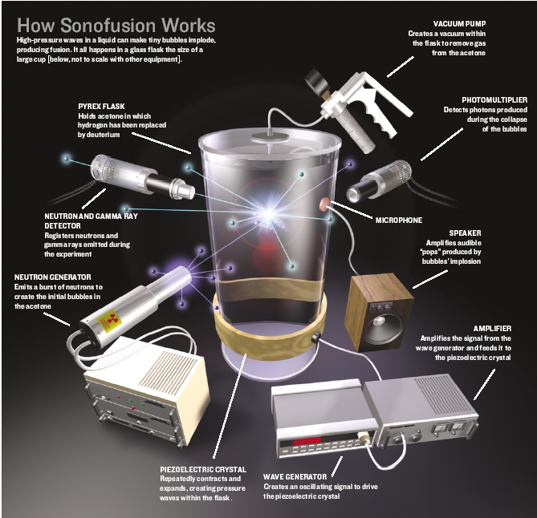

BASIC REQUIREMENTS

- Pyrex flask.
- Deuterated acetone (C₃D₆O).
- Vacuum pump.
- Piezoelectric crystal.
- Wave generator.
- Amplifier.
- Neutron generator.
- Neutron and gamma ray detector.
- Photomultiplier.
- Microphone and speaker.

SONOFUSION

The apparatus consists of a cylindrical Pyrex glass flask 100 m.m. in high and 65m.m.in diameter. A lead-zirconate-titanate ceramic piezoelectric crystal in the form of a ring is attached to the flask’s outer surface. The piezoelectric ring works like the loud speakers in a sonoluminescence experiment, although it creates much stronger pressure waves. When a positive voltage is applied to the piezoelectric ring, it contracts; when the voltage is removed, it expands to its original size.

The flask is then filled with commercially available deuterated acetone (C₃D₆O), in which 99.9 percent of the hydrogen atoms in the acetone molecules are deuterium (this isotope of hydrogen has one proton and one neutron in its nucleus). The main reason to choose deuterated acetone is that atoms of deuterium can undergo fusion much more easily than ordinary hydrogen atoms. Also the deuterated fluid can withstand significant tension (stretching) without forming unwanted bubbles. The substance is also relatively cheap, easy to work with, and not particularly hazardous.

- ACTION OF VACUUM PUMP:

The naturally occurring gas bubbles cannot withstand high temperature and pressure. All the naturally occurring gas bubbles dissolved in the liquid are removed virtually by attaching a vacuum pump to the flask and acoustically agitating the liquid.

- ACTION OF THE WAVE GENERATOR:

To initiate the sonofusion process, we apply an oscillating voltage with a frequency of about 20,000 hertz to the piezoelectric ring. The alternating contractions and expansions of the ring-and there by of the flask-send concentric pressure waves through the liquid. The waves interact, and after a while they set up
an acoustic standing wave that resonates and concentrates a huge amount of sound energy. This wave causes the region at the flask’s centre to oscillate between a maximum (1500kpa) and a minimum pressure. (-1500kpa).

- ACTION OF THE NEUTRON GENERATOR:

Precisely when the pressure reaches its lowest point, a pulsed neutron generator is fired. This is a commercially available, baseball bat size device that sits next to the flask. The generator emits high-energy neutrons at 14.1 mega electron volts in a burst that lasts about six microseconds and that goes in all directions.

- ACTION IN THE FLASK:

Stage 1:

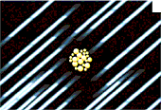 Figure: 2
Some neutrons go through the liquid, and some collide head on with the Carbon, oxygen and deuterium atoms of the deuterated acetone molecules. The fast moving neutrons may knock the atom’s nuclei out of their molecules as these nuclei recoil; they give up their kinetic energy to the liquid molecules. This interaction between the nuclei and the molecules create heat in regions a few nanometers in size that results in tiny bubbles of deuterated acetone vapor. Computer simulations, suggest that this process generates clusters of about 1000 bubbles, each with a radius of only tens of nanometers.

Stage 2:

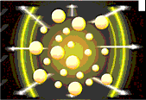 Figure: 3

By firing the neutron generator during the liquid’s low pressure phase, the bubbles instantly swell -a process known as cavitation. In these swelling phases, the bubbles balloon out 100,000 times from their nanometer dimensions to about one millimeter in size. To grasp the magnitude of this growth, imagine that the initial bubbles are the size of peas after growing by a factor of 100,000, each bubble would be big enough to contain the Empire State Building.
Stage 3:
Then the pressure rapidly reverses, the liquid pushes the bubbles’ walls inward with tremendous force, and they implode with great violence. The implosion creates spherical shock waves with in the bubbles that travel inward at high speed and significantly strengthen as they converge to their centers.

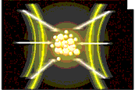 Figure: 4

The result, in terms of energy, is extra ordinary. Hydrodynamic shock-waves create, in a small region at the centre of the collapsing bubble, a peak pressure greater than 10 trillion kPa. For comparison, atmospheric pressure at sea level is101.3 kPa. The peak temperature in this tiny region soars above 100 million degree centigrade about 20.000 times that of the sun’s surface.

These extreme conditions within the bubbles-especially in the bubbles at the centre of the cluster, where the shock waves are more intense because of the surrounding implosions-cause the deuterium nuclei to collide at high speed. These collisions are so violent that the positively charged nuclei overcome their natural electrostatic repulsion and fuse.

The fusion process creates neutrons which we detect using a scintillator, a device in which the radiation interacts with a liquid that gives off light pulses that can be measured. This process is also accompanied by bursts of photons, which is detected with a photomultiplier. And subsequently, after about 20 microseconds, a shock wave in the liquid reaches the flask’s inner wall, resulting in an audible “pop”, which can be picked up and amplified by a microphone and a speaker.

- FUSION REACTIONS

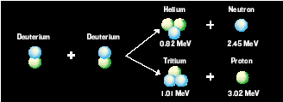 Figure: 5
Deuterium-Deuterium fusion has two probable outputs, helium and a 2.45-MeV neutron or tritium and a proton.

- IF TRITIUM IS PRODUCED:

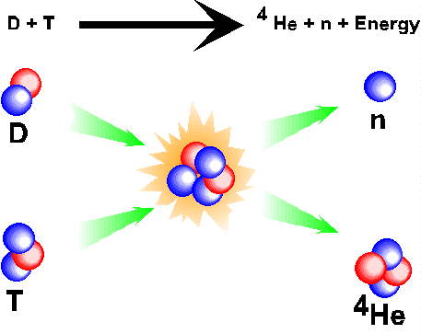 Figure: 6

The total neutron output would include not only the neutrons from deuterium-deuterium fusion, but also neutrons from deuterium-tritium fusion, since the tritium produced in sonofusion remains within the liquid and can fuse with deuterium atoms. Compared with deuterium-deuterium fusion, deuterium-tritium fusion occurs 1000 times more easily and produces more energetic neutrons increasing the neutron yield by about three orders of magnitude.

- SCHEMATIC OF SONOLUMINESCENE & SONOFUSION PHENOMENON

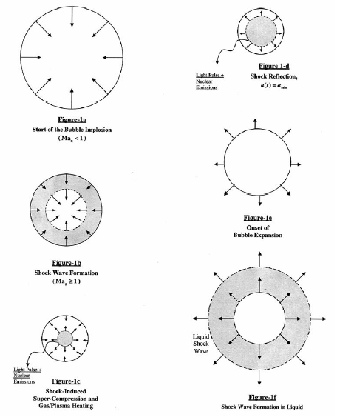

Figure: 7

- SEQUENCE OF EVENTS DURING SONOFUSION

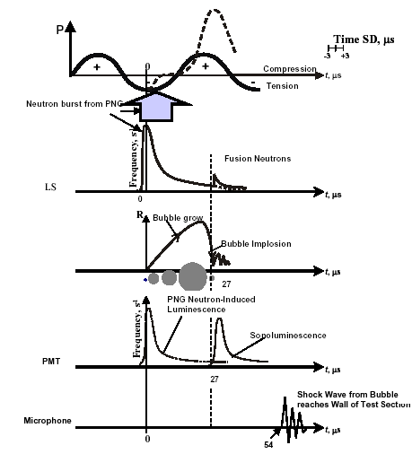

Figure: 8

- THE EVOLUTION OF LIQUID PRESSURE WITH IN BUBBLE CLUSTER

Figure: 9

SEPARATION OF DEUTERIUM FROM ORDINARY HYDROGEN (PROTIUM)

- SEPARATION FROM ORDINARY HYDROGEN BY DIFFUSION PROCESS:

Deuterium can be isolated from ordinary hydrogen by taking advantage of different rates of diffusion of the two isotopes. Protium, which is lighter, diffuses more readily than deuterium. The diffusion is carried out under reduced pressure. The lower the pressure, the greater is the efficiency of the process.

The process of diffusion is carried out in series of porous diffusion units, known as Hertz diffusion units. Each unit contains a porous membrane represented by dotted portion. As mixture is led into the diffusion units under reduced pressure, say from left to right, with the help of the mercury diffusion pumps P1, P2, P3. etc. The heavier component (deuterium) diffuses less readily and keeps behind while the lighter component (protium) diffusing at a faster move more and more to the right. The process is repeated several times, till ultimately, deuterium collects in the reservoir L on the left. The efficiency of the separation process can be increased by increasing the number of diffusing units.
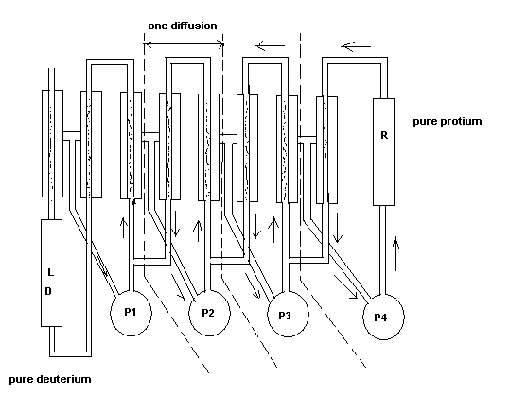
Figure: 10

- SEPARATION FROM ORDINARY HYDROGEN BY FRACTIONAL DISTILLATION:

Deuterium can be separated from ordinary hydrogen by careful fractional distillation of liquid hydrogen. Heavy hydrogen boils at -249.5 degree C while protium boils at a lower temperature of -282.5 degree C. Hence fraction distillation of liquid hydrogen can result in enrichment of the last fraction in deuterium, can be used for recovery of deuterium by the diffusion process described above.

- SEPARATION FROM ORDINARY HYDROGEN BY ADSORPTION ON CHARCOAL:

Protium is adsorbed more readily and more strongly on solid surfaces in general and on charcoal surface in particular. Thus when a mixture of the two isotopes is led over charcoal kept at liquid air temperature, most of the protium gets adsorbed while most of the deuterium passes out unchanged.

- SEPARATION FROM ORDINARY HYDROGEN BY CHEMICAL METHODS:

The lighter isotope (protium) is more reactive than the heavier isotope (deuterium). Thus when ordinary hydrogen is passed over red hot copper oxide, the lighter component is consumed more than the heavier one.

OTHER APPROACHES OF FUSION REACTION

There are mainly two approaches on fusion reactions other than bubble power. They are
- Laser Beam Technique.
- Magnetic Confinement Fusion.

- LASER BEAM TECHNIQUE

In this process extremely energetic laser beams converge on a tiny solid pellet of deuterium-deuterium fuel. The result is a shock wave that propagates towards the centre of the pellet and creates an enormous increase in temperature and density.

One of the drawbacks of this approach is the amount of power lasers required. This technique’s main goal is not producing energy but rather producing thermonuclear weapons.

- MAGNETIC CONFINEMENT FUSION

It uses powerful magnetic fields to create immense heat and pressure in hydrogen plasma contained in a large, toroidal device known as a tokamak. The fusion produces high energy by neutrons that escape the plasma and hit a liquid filled blanket surrounding it. The idea is to use the heat produced in the blanket to generate vapor to drive a turbine and thus generate electricity.

It is very much difficult to hold the plasma in place while increasing temperature and pressure. It is a very unstable process that has been proved difficult to control.

EVIDENCE TO SUPPORT TABLE TOP NUCLEAR FUSION DEVICE

There are two kinds of evidence that deuterium is fusing. The first neutron emission detected by the neutron scintillator. The device registers two clearly distinct bursts of neutron that are about 30 microseconds apart. The first is at 14.1 MeV, from the pulsed neutron generator; the second, how ever, is at 2.45 MeV. This is the exact energy level a neutron produced in a deuterium-deuterium fusion reaction is expected to have. These 2.45MeV neutrons are detected at about the same time that the photomultiplier detects a burst of light, indicating that both events take place during the implosion of the bubbles.

There is a second fusion “fingerprint” by measuring levels of another hydrogen isotope, tritium, in the deuterated acetone. The reason is that deuterium-deuterium fusion is a reaction with two possible outputs at almost equal probability. On possibility gives 2.45 MeV neutrone plus helium, and the other gives tritium plus a proton. Thus, the build-up of tritium above the measured initial levels is an independent and strong, indication that fusion has taken place, since tritium can not be produced with out a nuclear reaction.

The desktop experiment is safe because although the reactions generate extremely high pressures and temperature those extreme conditions exist only in small regions of the liquid in the container-within the collapsing bubbles.

ADVANTAGES OF BUBBLE POWER OVER OTHER APPROACHES

- It is self sustainable.
- Easily controllable.
- It consistently produces more energy than it consumes.
- Low cost.
- Easily available raw materials.
- Environmental friendly.

APPLICATIONS

- Thermonuclear fusion gives a new, safe, environmental friendly way to produce electrical energy.
- This technology also could result in a new class of low cost, compact detectors for security applications. That use neutrons to probe the contents of suitcases.
- Devices for research that use neutrons to analyze the molecular structure of materials.
- Machines that cheaply manufacture new synthetic materials and efficiently produce tritium, which is used for numerous applications ranging from medical imaging to watch dials.
- A new technique to study various phenomenons in cosmology, including the working of neutron star and black holes.

FUTURE DEVELOPMENTS

- FULLY SELF SUSTAINED:

To make the fusion reaction fully self-sustaining arranging the setup so it produces a continuous neutron output without requiring the external neutron generator. One of the possible ways is to put two complete apparatuses side by side so that they would exchange neutrons and drive each other’s fusion reactions. Imagine two adjacent sonofusion setups with just one difference: when the liquid pressure is low in one, it is high in the other. That is, their pressure oscillations are 180 degrees out of phase. Suppose hit the first apparatus with neutrons from the external neutron generator, causing the bubble cluster to form inside the first flask. Then turn off the neutron generator permanently. As the bubble cluster grows and then implodes, it will give off neutrons, some of which will hit the neighboring flask. If all is right, the neutrons will hit the second flask at the exact moment when it is at the lowest pressure, so that it creates a bubble cluster there. If the process repeats, get a self-sustaining chain reaction.

- TO CREATE A FULL-SIZE ELECTRICITY PRODUCING NUCLEAR GENERATOR:

A table top single apparatus yields about 400000 per second. The neutrons are an important measure of the output of the process because they carry most of the energy released in the fusion reaction. Yet that yield corresponds to a negligible fraction of a watt of power.

For operating a few thousand mega watts of thermal power, in terms of neutron-per-second, output of 10^22 neutrons per second needed. For this we will improve various parameters of Sonofusion process, such as the size of the liquid flask, the size of the bubbles before implosion and the pressure compressing the bubbles etc. then we installed a liquid filled blanket system around the reactor. All those high-energy neutrons would collide with it, raising its temperature. So that it heat could used to boil a fluid to drive a turbine and thus generate electricity.

CONCLUSION

With the steady growth of world population and with economic progress in developing countries, average electricity consumption per person has increased significantly. There fore seeking new sources of energy isn’t just important, it is necessary. So for more than half a century, thermonuclear fusion has held out the promise of cheap clean and virtually limitless energy. Unleashed through a fusion reactor of some sort, the energy from 1 gram of deuterium, an isotope of hydrogen, would be equivalent to that produced by burning 7000 liters of gasoline. Deuterium is abundant in ocean water, and one cubic kilometer of seawater could, in principle, supply all the world’s energy needs for several hundred years.

REFERENCES

- Richard T. Lahey Jr., Rusi P. Taleyarkhan & Robert I. Nigmatulin, bubble power, IEEE spectrum, page no: 30-35, may 2005.

- Fuels and combustion, author Samir Sarkar.

- Principles of Inorganic chemistry, authors – Puri, Sharma, Kalia.

- www.purdue.edu

- www.iter.org

- www.washington.edu

- www.rpi.edu

